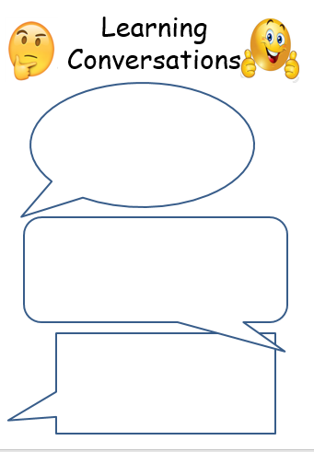 

English: Write a reading review for a current book that you are reading, use your green home reading booklet or a template from school (please ask to get one).

English: Write a reading review for a current book that you are reading, use your green home reading booklet or a template from school (please ask to get one).

Y4 Maths: Continued times tables focus: use the ‘u r brainy’ website to do the MTC test with the timer. TTRS is always good, too, the Soundcheck mode is the best one for practising for the test.

Y5 Maths:

Multiply a mixed number of your choice by an integer (use a die to get a random number), don’t forget to simplify the fraction if possible, e.g. 6/9 = 2/3

R.E.: Can you find out something about Ascension Day, which is on the 18thof May this year? What is being celebrated and why is it always on a Thursday?

R.E.: Can you find out something about Ascension Day, which is on the 18thof May this year? What is being celebrated and why is it always on a Thursday?

12.5.23

12.5.23

[Grab your reader’s attention with a great quote from the document or use this space to emphasize a key point. To place this text box anywhere on the page, just drag it.]