Topic Overview
Florence Nightingale and Mary Seacole were two significant people who changed the way people thought about nursing, women and race. They were extremely influential. Their work left a huge impact on the world today.
After they died, they left behind a legacy.
Who knows what the world would be like today without their changes!

Who was Florence Nightingale
Florence was born in 1820. She was born in a city called Florence, in Italy.
Florence wanted to become a nurse in 1850 when she was 30 years old but her parents didn’t want her to because nursing wasn’t seen to be an important job.
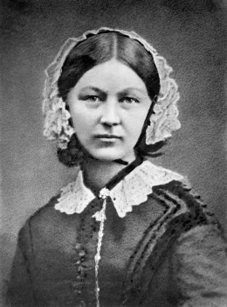
Florence wanted to improve this. When she became a nurse, she helped soldiers who had been in war. The hospitals weren’t in very good condition. They were insanitary. Florence changed all this by making sure they were clean and that the soldiers had good food to help them get better saving many lives.

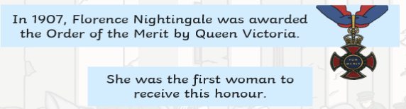

Societal Change
A big societal change that Florence Nightingale made was the cleanliness and hygiene in hospitals. She turned it from this,
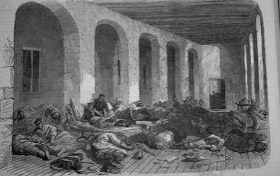 to this: 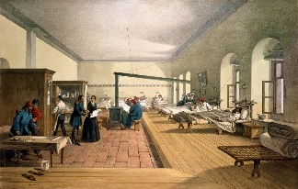
Mary Seacole showed that women of any colour and race can work in hospitals and didn’t give up this fight!
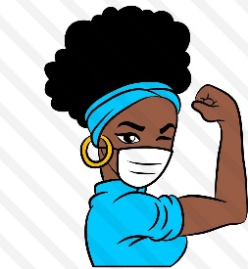
Who was Mary Seacole?
Mary was born in 1805 in Kingston, Jamaica.
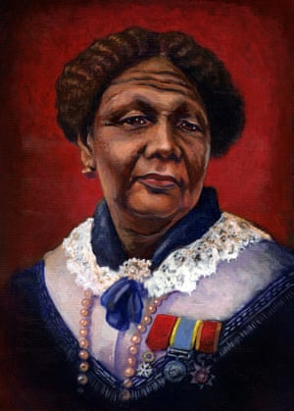
In 1854, Mary heard about the good work Florence was doing with the soldiers and wanted to help too but she was told she couldn’t because of her skin colour.
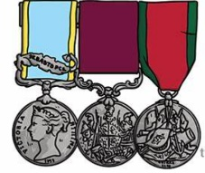
This only made Mary more determined to help so she set up her own hospital and paid for herself to be able to go to the war zone. When she returned to Britain, she was homeless and not very well herself. Everybody was very grateful of her work so they tried to help her. She also received medals.

Key Vocabulary
Significant- important

Improve- made better

Conditions- how good or bd a place is.

Legacy- something left behind after death

Influential- makes people notice

Insanitary- unclean
Top Take-Aways
At the end of the topic you should be able to:
- Explain what societal changes Florence Nightingale and Mary Seacole made to the world today.
- Describe the impact that these changes have made.
- What getting medical support used to be like before any changes were made.
- To describe the basic timeline of both FN and MS
