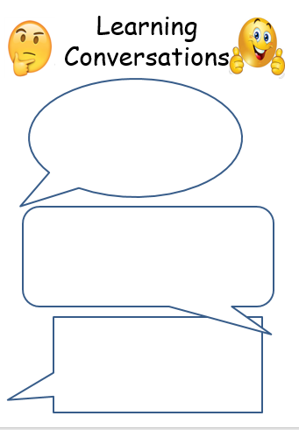 

History: Put together your costume for the assembly, so you can bring it in by next Wednesday (in a named bag, please). If you are stuck, let us know and we’ll help you.

History: Put together your costume for the assembly, so you can bring it in by next Wednesday (in a named bag, please). If you are stuck, let us know and we’ll help you.

English: Learn how to say your lines slowly and with emphasis on important words. Make pauses where needed.

Y5 Maths: Look at the way the 24-hour clock works: What patterns do you notice when converting from a 12h to a 24h clock time and the other way round? (e.g. 5 pm = 17:00)

English: Learn how to say your lines slowly and with emphasis on important words. Make pauses where needed.

Y4 Maths: Keep on practising your times tables! Use TT Rockstars or Hit the button, or write them out on sheets. Practise at a time when you are not tired.

17.03.23

17.03.23

[Grab your reader’s attention with a great quote from the document or use this space to emphasize a key point. To place this text box anywhere on the page, just drag it.]