**Key Vocabulary**

Attract – to pull towards

Balanced force - When two forces are equal and there is no movement

Compass - A device for finding directions by means of a magnetic needle pointing to the magnetic north

Contact force - Forces that act when two or more objects touch each other, eg friction

Force – a push or a pull

Friction - The force that acts when two objects touch each other. It is a contact force

Gravity - A force that pulls objects towards the ground

Magnet - An object that produces a magnetic force that pulls certain objects towards it

Magnetic Field - The invisible area around a magnet in which there is a magnetic force

Magnetic - The pushing or pulling force that acts between two magnets or between a magnet and magnetic materials

Non-contact force - Forces that do not need contact. They can act at a distance, eg magnetic force

Poles - North & South poles are found at different ends of the magnets

Pull – an object is moved towards something

Push – an object is moved away from something

Repel - To push backwards or away

Resistance - a force which slows down a moving object or vehicle

Top Takeaways

Having studied this topic you should be able to explain or describe;

●how things move on different surfaces

●that magnetic forces can act at a distance

●how magnets attract and repel each other

●how magnets attract some materials and not others

●which materials are magnetic and which are not

●that magnets have two poles

●whether two magnets will attract or repel each other depending on which poles are facing

**Forces and Magnets**

**Year 3**

**Forces can make things……..**

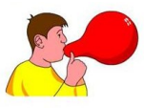

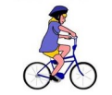

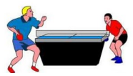

Change Shape

Change Speed

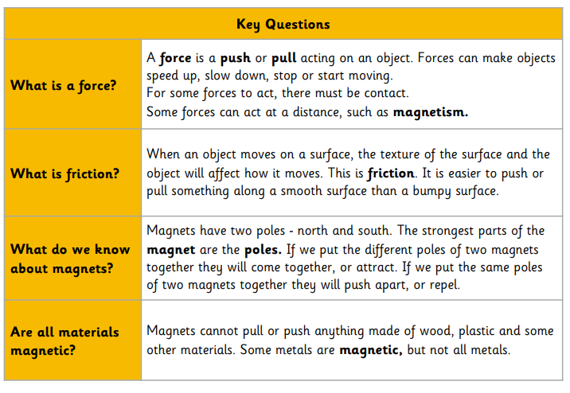

Change Direction

**Magnets**

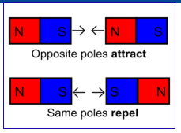

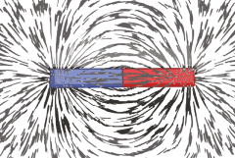

***Non-magnetic materials;*** wood, fabric, plastic

***Magnetic materials;***

Steel, nickel, iron, stainless steel

**Different Types of Magnets**

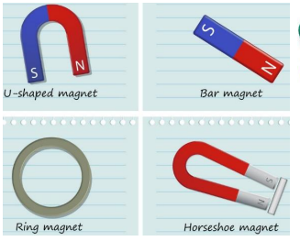

Forces are used to move things, usually by pushing or pulling an object. Magnets are objects which push or pull without physically touching the object, instead using magnetic fields

***A Magnetic Field*** is invisible but it can be seen here using iron filings.

***Scientific Skills***

● ask relevant questions and use different types of scientific enquiries to answer them

● gather, record, classify and present data in a variety of ways to help in answering questions

● record findings using simple scientific language, drawings, labelled diagrams, keys, bar charts, and tables

● identify differences, similarities or changes related to simple scientific ideas and processes