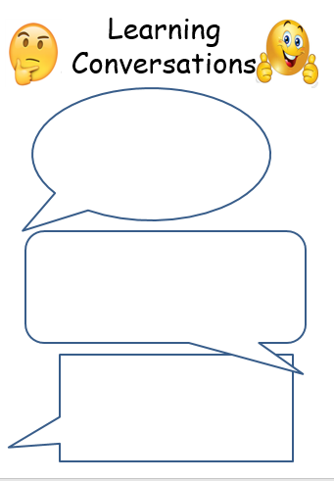 

Y5 Maths: Try to order these fractions from greatest to smallest (descending order): 5/8 ¼ 1/3 3/4 ½ 2/5 3/10 Think about how much you would get if a pizza was sliced into one of these….

Geography:

Can you tell somebody 3 differences between the UK and Greece. Can you also find a similarity?

English: Write a description about the Book Day character you are going to be – what kind of personality do they have? Would you like them as a friend?

Y4 Maths: Try to order these unit fractions from greatest to smallest (descending order): 1/8 ¼ 1/3 1/20 1/10 ½ 1/5 Think about how much you would get if a pizza was sliced into one of these….

Geography:

Can you tell somebody 3 differences between the UK and Greece. Can you also find a similarity?

English: Write a description about the Book Day character you are going to be – what kind of personality do they have? Would you like them as a friend?

24.2.23

24.2.23

[Grab your reader’s attention with a great quote from the document or use this space to emphasize a key point. To place this text box anywhere on the page, just drag it.]