Topic Overview
On the 5th November 1605 (Remember, Remember the fifth of November!) the houses of parliament were attempted to be blown up with the intentions of killing King James I.
Guy Fawkes and his friends (the plotters) had different beliefs to the King James I.
Guy Fawkes believed that the Roman Catholics were treated unfairly.
Guy Fawkes put together a plan to blow up the Houses of Parliament.
Guy Fawkes and his friends got caught and were imprisoned on the 5th November 1605.

You will learn about why this act of treason was attempted and how it has affected society today.
Rulers
King James I was not giving or showing the right support to Catholics and their religion.

King James I was always demanding for money and always thought he was right. This created a lot of conflict with parliament!

Societal Change
-The mistreatment of Catholics led Guy Fawkes and the plotters to carry out the attempt on blowing up parliament.
The group was fighting for social justice.

-People today are inspired by Guy Fawkes and his bravery and want to follow in his footsteps to end corruption and social injustice.

Who were the plotters?
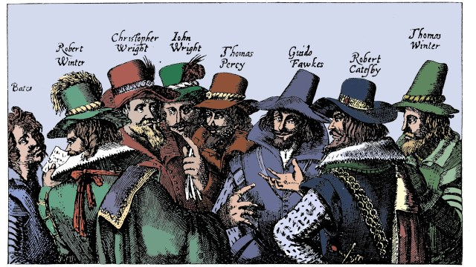Bates, Robert Winter, Christopher Wright, John Wright, Thomas Perry, Guido (Guy) Fawkes, Robert Catesby and Thomas Winter.

Key Vocabulary
Social Justice- fairness and equality
Social Injustice- no fairness or equality
Corruption- breaking trust.
Bravery
Guy Fawkes
Bonfire Night
Plot- secret plan to do something against the law, or harmful to others.
Gunpowder- chemical that explodes if set alight
Houses of Parliament- Buildings in London. Where the government meets.
Catholics- members of the Catholic Church
Conflict- a disagreement or argument
Top Take-Aways
At the end of the topic you should be able to:
- Describes Guy Fawkes life.
- Sequence the main events leading up to the 5th of November.
- Identify how The Gunpowder Plot is remembered today.
- Talk about who was important during the Gunpowder Plot.
- Recognise why Guy Fawkes wanted to blow up parliament.
