Chestnut Class Knowledge Organiser

Map Skills and the Local Area (Autumn 2)

Key vocabulary

**Aerial view** – the term aerial view can refer to any view from a great height or directly from above. Also known as a bird’s-eye view.

**Atlas** – a collection of maps in one book

**Compass** – a tool which shows people which direction they are travelling in

**Compass rose** – an image printed on a map to show different directions

**Coordinates** – points of intersection on a grid system

**Direction** – a course along which someone or something moves

**Human feature** – a feature that has been made or changed by humans, for example a bridge

**Key** – a collection of signs and symbols and their meanings

**Location** – a particular place or position

**Ordinance Survey** – the national mapping agency for the UK

**Orientate** – to move a map or plan in accordance to the points of a compass

**Plan view** – the appearance of an object from above

**Physical feature** – a feature that has been formed by nature

**Position** – a place where someone or something is located

**Route** – a way of getting from A to B

**Scale** – the relationship between a map and distance on the ground

**Side view** – the appearance of an object from the side

**Sketch map** – a simple map with only basic details

**Symbols** – a picture or sign on a map that represents something

Using an Atlas

An atlas shows maps of continents, countries, oceans and the physical features of a place, for example forests, lakes and rivers. The contents page shows a list of all the maps and the page on which they can be found. The index page lists, in alphabetical order, all of the countries, cities and towns that can be found in the atlas and shows which page number to look on.

Four figure Grid References

Along the edges of each map there are numbers. These numbers help you to work out where a location is on the map. Numbers that go from the bottom to the top of the page are called NORTHINGS. Numbers that go from left to right are called EASTINGS.

(HINT: Along the corridor and up the stairs)

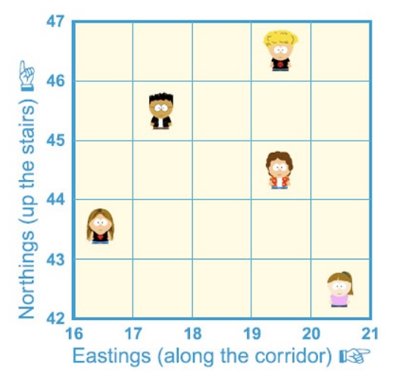

Eight Compass Points

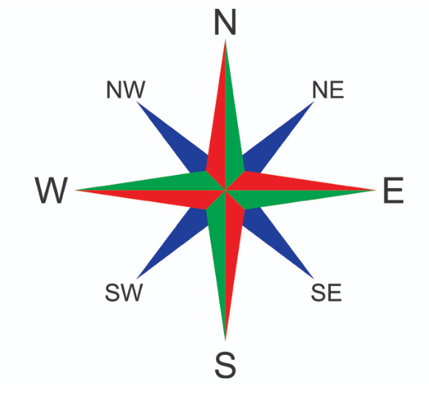

What is a map?

A map is a drawing of a place that uses lines and symbols to represent real-life objects. Maps are usually drawn from an aerial view. We can use aerial photographs to see the main human and physical features of a place. Aerial photographs are taken by aircraft or drones.

Types of Maps

There are many types of maps, such as sketch maps, road maps, ordinance survey maps and climate maps.

Did you know?

A map maker is called a **CARTOGRAPHER.**

The oldest maps were made on clay tablets.

Maps cannot possibly show everything – they are drawn to scale.

*a*

Top Takeaways

Having studied this topic you should be able to:

●interpret a map of Harting Village;

●use simple compass directions

●use locational and directional language to describe the location of features and routes on a map

●use aerial photographs and plan perspectives to recognise landmarks and simple human and geographical features

●devise a simple map

●use and construct symbols in a key

●use simple fieldwork and observational skills to study our school and its grounds as well as the human and physical features of our local environment

●use four figure grid references

●use geographical vocabulary such as cliff or vegetation

Map Symbols

Symbols are used as they are space saving, multi-lingual and clear.