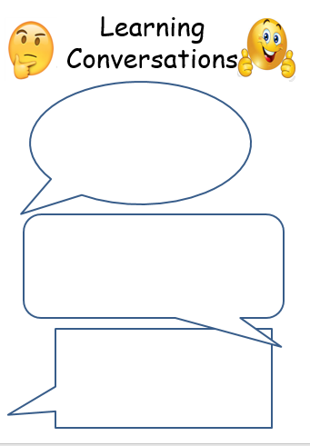 

Science: Observe the moon and fill out your moon phase sheet. The best viewing time is early evening around 6.30pm. If it’s cloudy, then use an online calendar to see the phase.

Y5 Maths:

Revise your fractions with your fortune tellers. Also have a look if you can find out what ‘Equivalent fractions’ are.

Science: Observe the moon and fill out your moon phase sheet. The best viewing time is early evening around 6.30pm. If it’s cloudy, then use an online calendar to see the phase.

English: Write a book review for one of your a favourite books – use the help sheet as a guide. Finished reviews will be displayed in the classroom.

Y4 Maths: Keep practising your times tables, especially the ones which are more tricky. Use TT Rockstars, Hit the Button or anything else which helps you learn.

English: Write a book review for one of your a favourite books – use the help sheet as a guide. Finished reviews will be displayed in the classroom.

3.03.23

3.03.23

[Grab your reader’s attention with a great quote from the document or use this space to emphasize a key point. To place this text box anywhere on the page, just drag it.]