|  |
| --- |
| England  The capital city of England is London.  It is the biggest country in the UK.  Its mountain is: Scafell Pike  Nick's Ramblings » Blog Archive » My Country’s Flag  Wales  The capital city of Wales is Cardiff.  It is bordered by the Irish Sea.  Its tallest mountain is: Snowdon  Wales flag package - Country flags  **Surrounding Seas**  The oceans that surrounds the UK are: **North Seam Atlantic Ocean, English Channel, Irish Sea and Celtic Sea.** |

|  |
| --- |
| Flag of Scotland: JPG PD PNG EPS SVG GIF and more – Flags Web  Scotland  The capital city of Scotland is Edinburgh.  It is the home of the Loch Ness Monster!  It has the tallest mountain in the UK: Ben Nevis.  NORTHERN IRELAND FLAG - Elmers Flag and Banner    Northern Ireland  The capital city of Northern Ireland is Belfast.  It is the smallest country in the UK |

|  |
| --- |
| Topic Overview |
| We will be looking at United Kingdom and its counties, identifying the capital cities and their surrounding seas. We will learn about each countries characteristics. |
| Key Vocabulary |
| |  |  | | --- | --- | | **United Kingdom** | A country made up of England, Scotland, Wales, and Northern Ireland. | | **England** | A country that is part of the UK, known for its history and culture. | | **Scotland** | A country that is part of the UK, known for its mountains and history. | | **Wales** | A country that is part of the UK, known for its distinct language and culture. | | **Northern Ireland** | A part of the UK located on the island of Ireland. | | **Capital** | The city where the government of a country or region is based. | | **Map** | A drawing that shows where places are located. | | **River** | A large, flowing body of water that usually empties into a sea or lake. | | **Country** | A large area of land that is controlled by its own government. | | **Culture** | The way of life, traditions, and beliefs of a particular group of people. | |
| Top Takeaways |
| To name, locate and identify the four UK countries  To name, locate and identify the UK capital cities  To name, locate and identify the surrounding seas  To use world maps, atlases and globes to identify the UK |

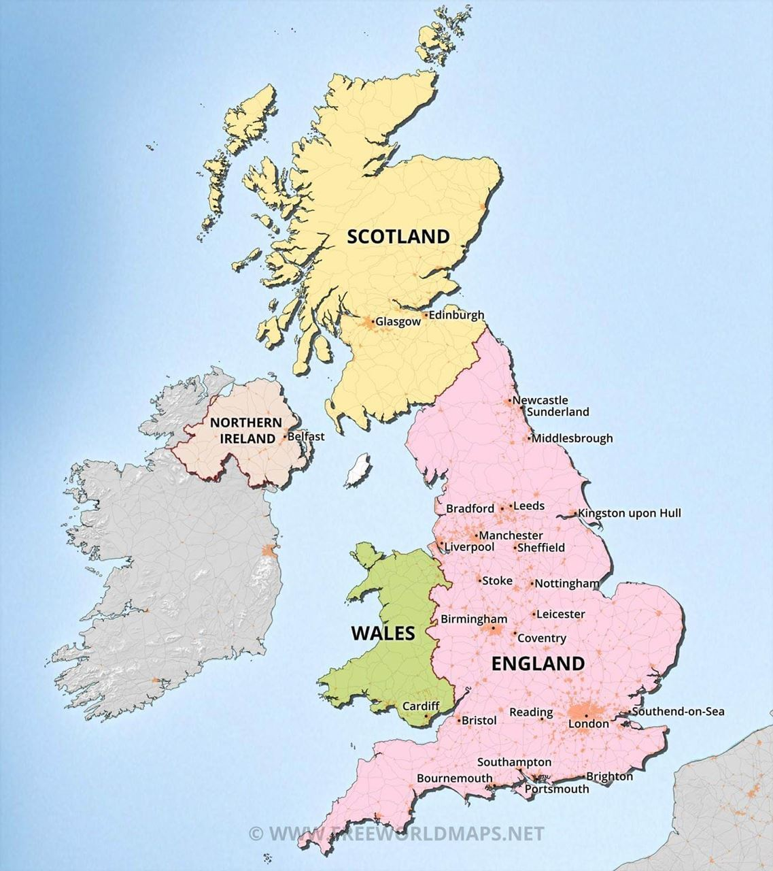

**Atlantic Ocean**

**North Sea**

**English Channel**

**Celtic Sea**