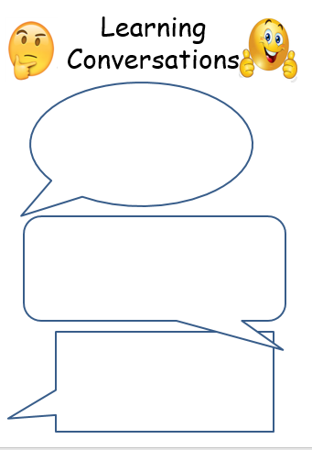 

Maths (until after half-term): Be a fractions and decimals detective – where can you find them in everyday life? Look at recipes ( ½ a teaspoon, ¼ of a cup), packaging (1.5 kg of flour), adverts, magazines, etc… Make a list.

Maths (until after half-term): Be a fractions and decimals detective – where can you find them in everyday life? Look at recipes ( ½ a teaspoon, ¼ of a cup), packaging (1.5 kg of flour), adverts, magazines, etc… Make a list.

ICT: On Tuesday, 7th February is UK Safer Internet Day. Make a poster about what you have found out (in school and at home) and why it is important to be safe on the web. Bring it in after half-term for our display.

ICT: On Tuesday, 7th February is UK Safer Internet Day. Make a poster about what you have found out (in school and at home) and why it is important to be safe on the web. Bring it in after half-term for our display.

English (until after half-term): Choose your favourite poem and bring it to school. What is it about? Why do you like it? Try to learn it off by heart.

English (until after half-term): Choose your favourite poem and bring it to school. What is it about? Why do you like it? Try to learn it off by heart.

6.2.23

6.2.23

[Grab your reader’s attention with a great quote from the document or use this space to emphasize a key point. To place this text box anywhere on the page, just drag it.]