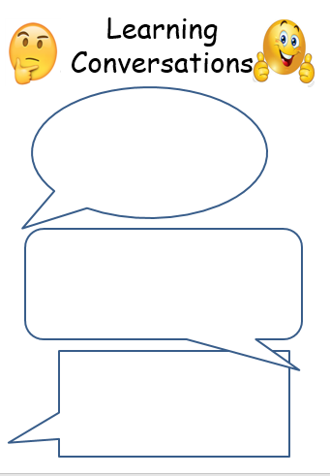 

English: Recall the key features of persuasive devices. You could write a letter to persuade Mr Tidey to get a swimming pool or zip wire for the school.

English: Recall the key features of persuasive devices. You could write a letter to persuade Mr Tidey to get a swimming pool or zip wire for the school.

Year 5:

Big push on Times Tables Rockstars.

Year 4:

Big push on Times Tables Rockstars.

Science: Observe the birds around your home for the RSPB’s Big Garden Birdwatch Weekend.

Science: Observe the birds around your home for the RSPB’s Big Garden Birdwatch Weekend.

27.1.23

27.1.23

[Grab your reader’s attention with a great quote from the document or use this space to emphasize a key point. To place this text box anywhere on the page, just drag it.]