**Electricity - Year 4/5**

Electricity is a flow of charged particles. An important form of energy, electricity powers things around us. We use it every day in our homes to power lights, TVs, computers, fridges, and ovens.

**Top Takeaways**

* identify common appliances that run on electricity
* construct a simple series electrical circuit, identifying and naming its basic parts, including cells, wires, bulbs, switches and buzzers
* identify whether or not a lamp will light in a simple series circuit, based on whether or not the lamp is part of a complete loop with a battery
* recognise that a switch opens and closes a circuit and associate this with whether or not a lamp lights in a simple series circuit
* recognise some common conductors and insulators, and associate metals with being good conductors



**Key Vocabulary**

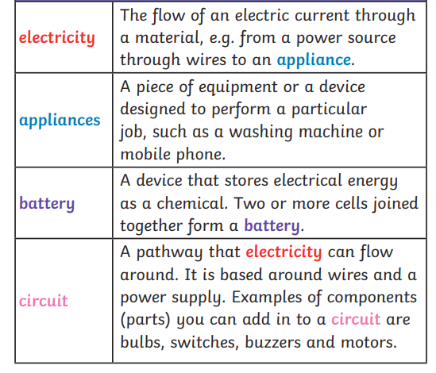

**Scientific Skills**

♣ asking relevant questions and using different types of scientific enquiries to answer them

♣ setting up simple practical enquiries, comparative and fair tests

♣ making systematic and careful observations

♣ recording findings using simple scientific language, drawings, labelled diagrams, keys

♣ using results to draw simple conclusions, make predictions for new values, suggest improvements and raise further questions

♣ using straightforward scientific evidence to answer questions or to support their findings.

♣planning different types of scientific enquiries to answer questions, including recognising and controlling variables where necessary

♣ reporting and presenting findings from enquiries, including conclusions, causal relationships and explanations of and degree of trust in results, in oral and written forms such as displays and other presentations

♣ identifying scientific evidence that has been used to support or refute ideas or arguments.

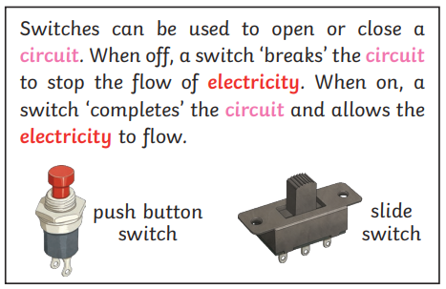

YEAR 4

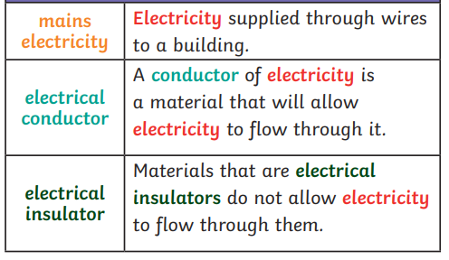

YEAR 5

