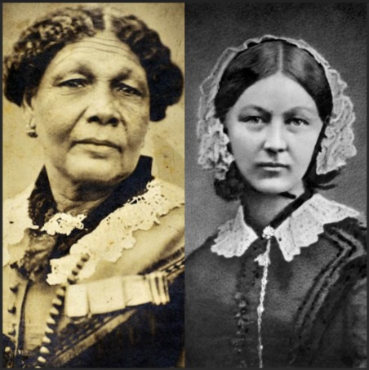

**English**

**Core Text- Hermelin, The Detective Mouse by Mini Grey**

Outcome 2 – Letter

Purpose: To recount

Build on previous units & focus on: Reinforce plural noun suffix -s/-es Adding the suffixes -er and –est to adjectives. How the prefix un – changes the meaning of verbs and adjectives

Build on previous units & focus on: Combining words to make sentences Joining words and clauses using ‘and’

Build on previous units & focus on: Sequencing sentences to form short narratives

Build on previous year & focus on: Separation of words with spaces Capital letters Full Stops Question Marks Exclamation Marks.

Maths

**Number: Addition and Subtraction (within 10)**

•Derive some number bonds within 10

• Represent number bonds in different ways;

• Use number bonds in a practical context;

• Read and write mathematical statements involving the

addition, subtraction and equals signs;

• Count back to subtract;

*Children will extend themselves by looking at numbers to 20 and how number bond facts to 10 can help with adding up to 20*

**Number: Place Value (within 20)**

• Read and write numbers in numerals to 20.

Count up to and back from 20 in ones;

• Order numbers up to 20

• Identify and represent numbers using objects

and pictures, and begin to use number lines;

• Find the least and the most when comparing numbers;

• Find one more and on less than numbers up to 20

*Children will extend themselves by separating the tens and the ones..*

**Geometry: Shapes (2D and 3D)**

Recognise and name common 2D and 3D shapes.

Make pictures and patterns with 2D shapes (models with 3D)

Recognise 2D and 3D shapes in real life.

Recognise 2D and 3D shapes in different sizes and orientations.

Willow Class Spring 1 2025

In Gymnastics we will be:

Performing sequences of body shapes. (Mondays)

In Games with Mr Gardiner we will be:

Focusing on team work and movement. (Wednesdays)

Dungeons and Dragons

In Computing we will be:

Thinking about how to ‘say no when we’re online’.

Programming floor robots using a sequence of commands.



R.E- Judaism

**Why is learning to do good deeds so important to Jewish people?**

Computing

Programming a robot.

**Music - Football**

This unit sees children echo singing, composing word patterns, improvising with mi-re-do, and playing a percussion ostinato. Activities will support pupils to understand the difference between pitched patterns and rhythm patterns, higher and lower.

**PSHE - Dreams and Goals**

Thinking about our dreams and goals and what the steps might be to get to those goals.

**P.E on Tuesdays**

**Gymnastics**–developing balance, agility and co-ordination

Mr Gardner will teach PE outside on **Wednesday mornings,** weather permitting.

**Science – Animals including Humans**

♣ identify and name a variety of common animals including fish, amphibians, reptiles, birds and mammals ♣ identify and name a variety of common animals that are carnivores, herbivores and omnivores Science – key stages 1 and 2 8 Statutory requirements ♣ describe and compare the structure of a variety of common animals (fish, amphibians, reptiles, birds and mammals, including pets) ♣ identify, name, draw and label the basic parts of the human body and say which part of the body is associated with each sense.

**History-** Learning about Florence Nightingale and Mary Seacole, discovering how their work made changes to society.

**Historical Enquiry:** How did these people make a difference in the world over time?

**Art – Playful Making**

#### In this pathway children are introduced to what sculpture can be, and invited to explore the work of other sculptors whilst taking a playful and inventive approach to making their own sculptures. Children will be encouraged to start voicing their response to sculptural artworks, including their own, and given time and space to explore properties of materials, and what happens when you join one or more materials together to construct new forms.