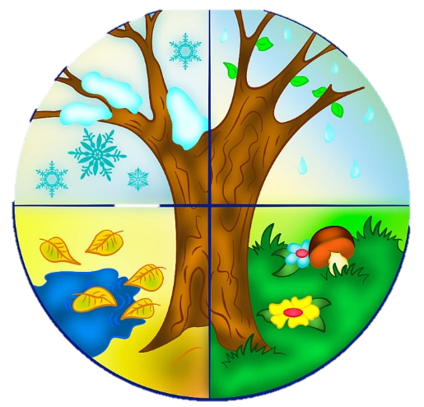

**English**

**Vehicle Text – Old Bear**

This half term we will look at how words can be combined together to form **sentences**.

We will practice spelling words by using our phonics and our sounds.

We will look at how to accurately punctuate our writing, using capital letters, finger spaces and full stops.

We will draft and write ideas down.

**Writing Outcomes & Writing Purpose**

1)Narrative: Finding Narrative

Purpose: To retell a story

2)Recount: Messages

Purpose: To inform and explain events that have happened

**Maths**

**Number: Place Value (within 10)**

• Read and write numbers in numerals to 10.

Count up to and back from 10 in ones;

• Order numbers up to 10

• Identify and represent numbers using objects

and pictures, and begin to use number lines;

• Find the least and the most when comparing numbers;

• Find one more and on less than numbers up to 10

*Children will extend themselves by looking at numbers up to 20.*

**Number: Addition and Subtraction (within 10)**

•Derive some number bonds within 10

• Represent number bonds in different ways;

• Use number bonds in a practical context;

• Read and write mathematical statements involving the addition, subtraction and equals signs;

• Count back to subtract;

*Children will extend themselves by looking at numbers to 20 and how number bond facts to 10 can help with adding up to 20*

Willow Class Autumn 1 2024

In Gymnastics we will be:

Performing sequences of body shapes. (Mondays)

In Games with Mr Gardiner we will be:

Focusing on team work and movement. (Wednesdays)

Dungeons and Dragons

In Computing we will be:

Thinking about how to ‘say no when we’re online’.

Programming floor robots using a sequence of commands.

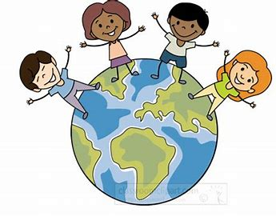

**R.E** **Christianity -** Who made the world?

Seasons and Weather Patterns

**PSHE Being me in my world.**

Thinking about the choices we make and the consequences of what we choose. Thinking about our role within the community.

**Geography-**

Looking at seasonal weather changes, using our observational skills to describe weather changes in each season.

**Geographical Enquiry: What do the seasons mean for humans, animals and the landscape?**

**Computing**

Computing systems and networks – Technology around us

**P.E Tuesday afternoons**

Dance – using simple movements and patterns to portray the seasons and its weather. Mr Gardner will teach PE outside on **Wednesday mornings**, weather permitting.

**Science –** with Mrs Fourie on Wednesdays

Observe changes across the four seasons Observe and describe weather associated with the seasons and how day length varies. Asking simple questions and recognising that they can be answered in different ways.

Observing closely, using simple equipment. Performing simple tests

Identifying and classifying

Using their observations and ideas to suggest answers to questions

Gathering and recording data to help in answering questions.

**Homework:**

Please continue to read with and to your children, as well as going over the HRS words.

Learning conversations will be sent home every Friday.

Library books will be changed weekly.

**Art** **Explore & Draw:**

Children explore observational drawing and experimental mark making, and think about how they can use composition to create their artwork. Children will be encouraged to begin developing hand-eye coordination through slow and paced looking. This is balanced by encouraging children to nurture a playful exploration of media, a curiosity towards the world around them, and to begin to take creative risks.