Topic Overview
- Seasons are different times in the year when the weather changes.
- In places like the UK there are 4 seasons in a year: Spring, Summer, Autumn and Winter.
- The seasons have an effect on landscapes and plant and animal life.
The 4 seasons:
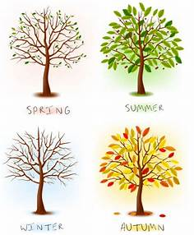

Day Length Changes
- In the UK the day length is longer in the summer.
- The day length is shorter in the winter.
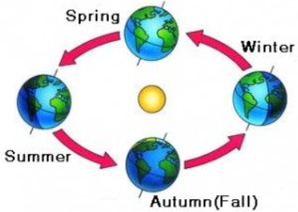

The seasons are caused because our planet is on a tilt. As the Earth moves around the sun different places on Earth are in the sun more.
When we are tilted near the sun it is summer!
When we are tilted away from the sun in is winter!
How do we know which season is which?
Summer- This is the hottest time of the year.
Spring- This is when the flowers start to bloom and it is getting warmer
Autumn- This is when the leaves are falling of the trees and it is getting colder.
Winter- This is the coldest time of the year.

Key Vocabulary
Sun Beaufort scale
Day length A rain gauge
Temperature Tilt
Seasons
Weather
Spring
Summer
Autumn
Scorching
Rainfall
Top Take-Aways
At the end of the topic you should be able to:

Describe and observe the weather changes in each season.
Describe and observe weather associated with each season and how day length varies.

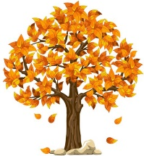
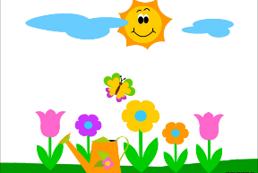
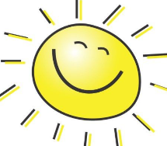

Seasons throughout the year!


Winter |  | Spring |  |  | Summer |  |  | Autumn |  |  | Winter
January | February | March | April | May | June | July | August | September | October | November | December

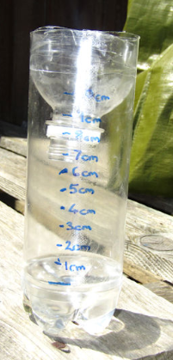
Willows Weather Station- How can we meaure rain and wind?

The Beaufort Scale- this measure how much wind there is. A Rain Gauge- this is how we can measure rainfall.
