Harting C of E Primary School – Science

Topic: FORCES & MAGNETS | Years 4 & 5 | SUMMER I
Important Information
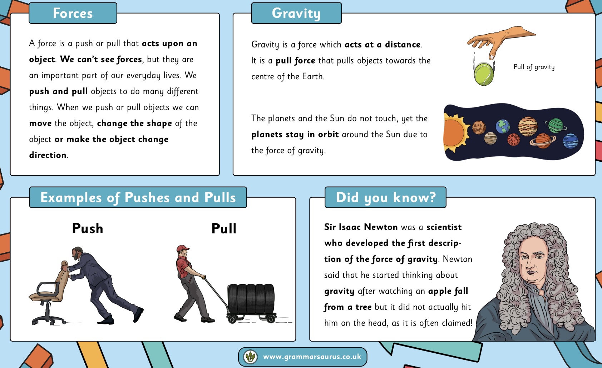

Forces & Magnets (Y4/5)

Within this unit, children will be able to:
- explain that unsupported objects fall towards the Earth because of the force of gravity acting between the Earth and the falling object
- identify the impact of air resistance, water resistance and friction, that act between moving surfaces
- recognise that some mechanisms, including levers, pulleys and gears, allow a smaller force to have a greater impact
Investigations: Which surface provides the best friction for a shoe? Which material provides the most friction?
How can we test air resistance using parachutes?
Progression of skills in Science: Working Scientifically
Year 4
Throughout the year, pupils will:
- ask relevant questions and use different types of scientific enquiries to answer them
- set up simple practical enquiries, comparative and fair tests
- make systematic and careful observations and, where appropriate, take accurate measurements using standard units, using a range of equipment, including thermometers and data loggers
- record findings using simple scientific language, drawings, labelled diagrams, keys, bar charts, and tables
- gather, record, classify and present data in a variety of ways to help in answering questions
- identify differences, similarities or changes related to simple scientific ideas and processes
- report on findings from enquiries, including oral and written explanations, displays or presentations of results and conclusions
- use straightforward scientific evidence to answer questions or to support their findings
- use results to draw simple conclusions, make predictions for new values, suggest improvements and raise further
questions
Year 5
Throughout the year, pupils will:
- plan different types of scientific enquiries to answer questions, including recognising and controlling variables where necessary
- take measurements, using a range of scientific equipment, with increasing accuracy and precision, taking repeat readings when appropriate
- record data and results of increasing complexity using scientific diagrams and labels, classification keys, tables, scatter graphs, bar and line graphs
- identify scientific evidence that has been used to support or refute ideas or arguments
- report and present findings from enquiries, including conclusions, causal relationships and explanations of and degree of trust in results, in oral and written forms such as displays and other presentations
- use test results to make predictions to set up further comparative and fair tests

