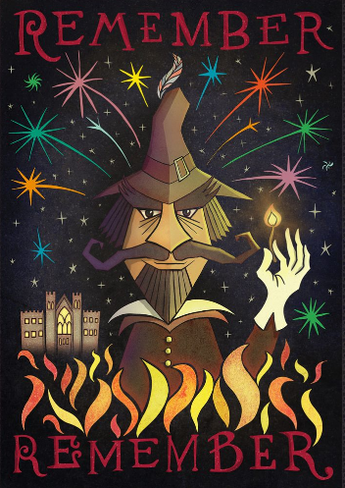

**English**

**Core Text- Rapunzel, Bethan Woollvin**

Outcome 1 - Narrative: A Traditional Tale

Purpose: To narrate

Outcome 2 -Instructions: How to catch a witch

Purpose: To instruct

Build on previous units & focus on: Reinforce plural noun suffix -s/-es Adding the suffix -er to verbs

Build on previous units & focus on: Combining words to make sentences Joining words and clauses using ‘and’

Build on previous units & focus on: Sequencing sentences to form short narratives

Build on previous year & focus on: Separation of words with spaces Capital letters Full Stops

Maths

**Number: Addition and Subtraction (within 10)**

•Derive some number bonds within 10

• Represent number bonds in different ways;

• Use number bonds in a practical context;

• Read and write mathematical statements involving the

addition, subtraction and equals signs;

• Count back to subtract;

*Children will extend themselves by looking at numbers to 20 and how number bond facts to 10 can help with adding up to 20*

**Number: Place Value (within 20)**

• Read and write numbers in numerals to 20.

Count up to and back from 20 in ones;

• Order numbers up to 20

• Identify and represent numbers using objects

and pictures, and begin to use number lines;

• Find the least and the most when comparing numbers;

• Find one more and on less than numbers up to 20

*Children will extend themselves by separating the tens and the ones..*

**Geometry: Shapes (2D and 3D)**

Recognise and name common 2D and 3D shapes.

Make pictures and patterns with 2D shapes (models with 3D)

Recognise 2D and 3D shapes in real life.

Recognise 2D and 3D shapes in different sizes and orientations.

Willow Class Autumn 2 2024

In Gymnastics we will be:

Performing sequences of body shapes. (Mondays)

In Games with Mr Gardiner we will be:

Focusing on team work and movement. (Wednesdays)

Dungeons and Dragons

In Computing we will be:

Thinking about how to ‘say no when we’re online’.

Programming floor robots using a sequence of commands.



**Computing**

Creating Media- Digital Painting

**History- Gunpowder plot.**

We will be looking at who Guy Fawkes was and why he wanted to blow up parliament.

We will be looking at how this event has changed society to this day.

**PSHE Celebrating differences**

Accepting that everyone is different and that is okay!

**DT**

**Mechanisms: Wheels and Axles.** Designing a horse and cart to transport Guy Fawkes’ gunpowder barrels (linking with our History topic)

**P.E on Tuesday afternoons**

**Gymnastics**–developing balance, agility and co-ordination

Mr Gardner will teach PE outside on **Wednesday mornings,** weather permitting.

**Science**

Distinguish between an object and the material from which it is made.

Identify and name a variety of everyday materials.

Describe the simple physical properties of a variety of everyday materials

Compare and group together a variety of everyday materials.

Asking simple questions and recognising that they can be answered in different ways.

Observing closely, using simple equipment. Performing simple tests

Identifying and classifying

Using their observations and ideas to suggest answers to questions

Gathering and recording data to help in answering questions.

**R.E**

Why does Christmas matter to Christians?

**GUNPOWDER PLOT**