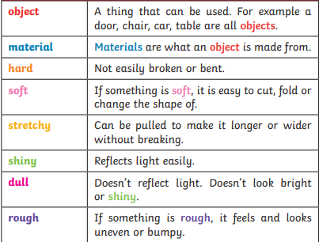

**Key Vocabulary – Properties**

Properties of everyday materials

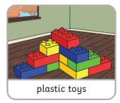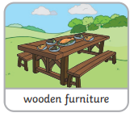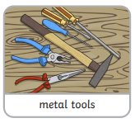

**Everyday Materials**

**Year 1**

By the end of this area of learning you should be able to:

* Distinguish between an object and the material from which it is made
* Identify and name a variety of everyday materials.
* Describe the simple physical properties of a variety of everyday materials
* Compare and group together a variety of everyday materials on the basis of their simple physical properties.
* Record observations

Materials

-A material is soemthing we can use to make different objects.

-Different materials have different properties.

-Some properties describe how an object looks and feels.

-There are lots of different materials around us.

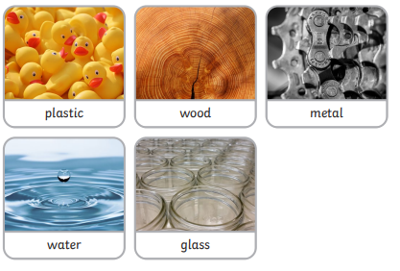

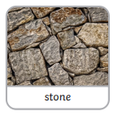

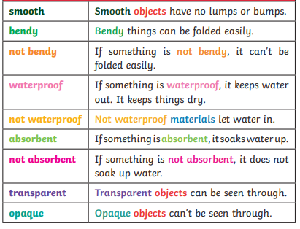

Objects

-An objects is something we can see or touch.

-Objects can be made from lots of different materials.

-The materials are chosen because of their properties.



rock

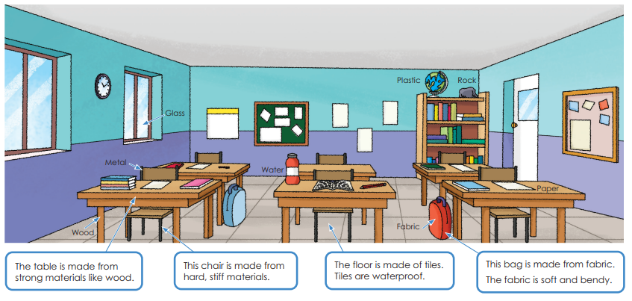

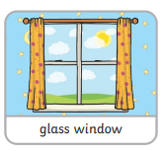

***Scientific Skills***

● ask relevant questions and use different types of scientific enquiries to answer them

● gather, record, classify and present data in a variety of ways to help in answering questions

● record findings using simple scientific language, drawings, labelled diagrams, keys, bar charts, and tables

● identify differences, similarities or changes related to simple scientific ideas and processes