

Willow Class Summer 1 2024-25

English

**Core Text- The Secret of the Black Rock**

This half term we will continue to look at how words can be combined together to form **sentences**.

We will continue practicing spelling words by using our phonics and our sounds.

We will look at how to accurately punctuate our writing, using capital letters, finger spaces and full stops.

We will draft and write ideas down.

We will compose and rehearse sentences orally using the ‘Think it, Say it, Write it’ technique.

We will look further at adjectives and including these into sentences.

We will look at capital letters at the beginning of names and places.

We are going to look more at editing our work and amending it where need be with our purple pens.

We will be looking at adding prefixes and suffixes to our words, including distinguishing between –s and –es.

Maths

**Multiplication and Division**

• Solve one step problems

• Group objects in twos, fives and tens

• Count objects in twos fives and tens

• Count the number of groups they have made.

• Find how many groups make a given total

• Find the total number of objects by counting in groups

• Double a number using equipment;

• Find half of a number using equipment;

• Use doubling and halving to solve problems;

**Measurement; Mass and Weight**

• Compare mass and weight using appropriate vocabulary

• Begin to measure mass and weight using standard units

• Solve simple practical problems about mass and weight

**Geometry: Position and Direction**

• Describe position, direction and movement, including whole, half, quarter and three quarter turns.

In Gymnastics we will be:

Performing sequences of body shapes. (Mondays)

In Games with Mr Gardiner we will be:

Focusing on team work and movement. (Wednesdays)

Dungeons and Dragons

In Computing we will be:

Thinking about how to ‘say no when we’re online’.

Programming floor robots using a sequence of commands.

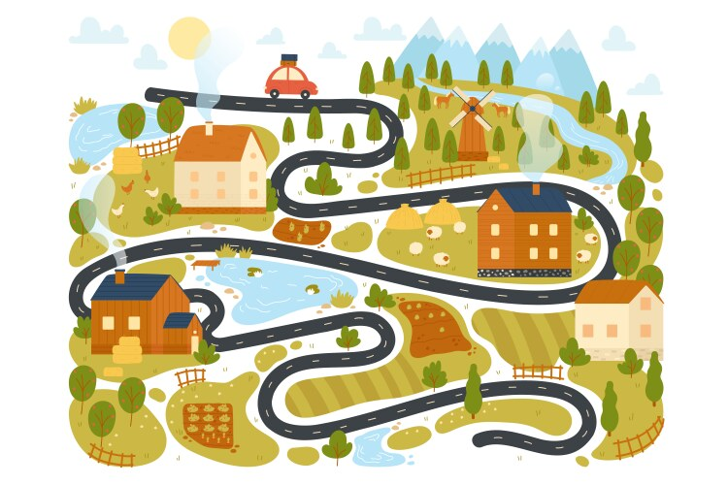



R.E - Judaism

Why do Jewish families say so many prayers and blessings?

P.E on Tuesday afternoons: Striking & Fielding

Mr Gardner will teach PE outside on Wednesday mornings, weather permitting.

PSHE **Relationships**

Looking at the relationships we have with others and how we can solve any issues within them.

Computing - Creating media- digital writing.

Geography- Mapping Our Local Area

Science

Identify and name a variety of common wild and garden plants, including deciduous and evergreen trees

Identify and describe the basic structure of a variety of common flowering plants, including trees.

Observe changes across the four seasons Observe and describe weather associated with the seasons and how day length varies **(this is continuous throughout the year)**.

Observing closely, using simple equipment. Performing simple tests

Identifying and classifying

Using their observations and ideas to suggest answers to questions

Gathering and recording data to help in answering questions.

Mapping Our Local Area

**Music**

Nautilus - **Through this music piece, pupils will develop their feeling and understanding of pitch, beat, and duration. They will listen actively to the piece, interpreting its gestures in dance. They will engage imaginatively with the piece by drawing to the music. Finally, they will compare their interpretations with contrasting animations and videos, discovering that music can be interpreted in a myriad of ways.**

Cat & Mouse - This unit uses a singing game as a starting point for improvising rhythms and then reading and writing them in simple notation. It also explores how we use a combination of musical elements – rhythm, tempo, timbre, and dynamics – to create an emotional response that helps us tell a story.

Art

In this pathway children are introduced to the idea that artists often work in partnership and are often inspired by other art forms – in this case music and the visual arts.

Children explore how other artists have used sound to inspire their artwork, and then go on to experiment with how they can use their mark making skills to both be influenced by, and to capture, the expression in music.

PSHE **Healthy Me**

Looking at how we can make healthy choices.

Homework:

Please read with and to your children. Reading books will be changed every Tuesday.

Learning conversations will be sent home every Friday.

Library books will be changed on Fridays.

Please bring books and items relevant to the topic into school for sharing with the class on Fridays.