Topic Overview
During this period England emerged as a recognisable nation and Christianity became established. King Alfred was the central Saxon figure, the only king to be called ‘Great’. He was responsible for defeating the Vikings who threatened to control the country for many years through raids and then attempts to conquer. The Saxon period is often called the Dark Ages but many think this is unfair as the Saxons were skilled craftsmen who introduced new long-lasting systems of keeping law and order as well as memorable literature.
Rulers and Invasion
Anglo-Saxon Kings
The kings of Anglo-Saxon Britain each ruled their own kingdom and the people in it. They fought to defend their kingdom or take control of other kingdoms. When the Anglo-Saxons first settled in Britain, there were seven kingdoms, but by AD 878 there was just one kingdom left (Wessex) as the others had been overrun by the Vikings. Many Anglo-Saxon kings tried to resist the Vikings and fought hard to keep control of their land. King Alfred the Great was the first to defeat the Vikings in battle.
Viking Invasion
The Vikings came from the modern Scandinavian countries of Denmark, Norway and Sweden. They travelled in boats called longships and first arrived in Britain around AD 787. The Vikings raided places such as monasteries and pillaged expensive items to trade. They were looking for valuable goods like gold and jewels, imported foods and other useful materials.
1066
William, the Duke of Normandy, thought he should be king so came to fight Harold II in the Battle of Hastings (AD 1066). Harold was shot through the eye with an arrow and died in the battle. William of Normandy, who became known as William the Conqueror, became King, bringing the Viking and Anglo-Saxon age to an end in AD 1066.

Settlement and Societal Change
The Anglo-Saxons were a mix of tribes from Germany, Denmark and the Netherlands. The three biggest were the Angles, the Saxons and the Jutes. The land they settled in became known as 'Angle-land', or England.
Religion
Paganism- When the Anglo Saxons arrived in Britain they were Pagan, this meant they believed in lots of different Gods and Goddesses who were all in charge of different parts of life.
Christianity- In 597AD, the Pope sent Augustus to convert the Anglo Saxons to Christianity. Over the next 100 years, Britain gradually changed from Pagan to Christian.
Law and Order
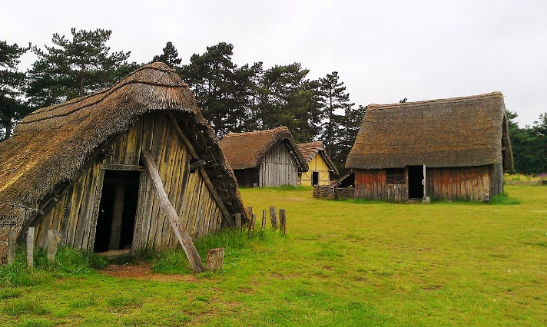
The Anglo-Saxon laws were very similar to some we have today, although the punishments were very different. These were often very brutal and would be carried in public to act as deterrents, to discourage others from committing such crimes. Stoning, whipping and exile were common punishments; as well as paying a fine (wergild), or receiving reparations in the form of hot or cold water ordeals..

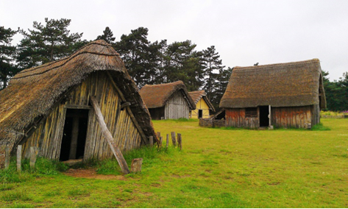
Houses
Anglo-Saxon houses were made from wood with thatched roofs. They had only one room where everyone ate, cooked, slept and entertained their friends.

Key Vocabulary
Danegeld- “Paying the Dane”. The money paid to Vikings to persuade them to return home.
Exile- To be sent away.
Invade- To enter and occupy land.
Kingdom- An area ruled by a king.
Longship- A long, wooden, narrow boat used by the Vikings.
Paganism- A religion where many gods and goddesses are worshipped.
Pillaged- To violently steal something.
Raid- A surprise attack.
Wergild- A payment system used to settle disputes between a criminal and the victim or their family.

Top Take-Aways
Having studied this topic you should be able to:

- Explain why, when and where the Anglo-Saxons and Vikings invaded Britain.
- Describe life on an Anglo-Saxon settlement.
- Name some Anglo-Saxon kings and understand why King Alfred was named ‘Great’.
- Discuss whether the Anglo-Saxon period really was the ‘Dark Ages’ with reference to entertainment, homes, and law and order.
- Explain how lives changed when Christianity came to Britain.
- Describe the events of 1066.

Timeline

