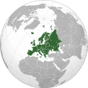

**EUROPE**

KNOWLEDGE ORGANISER

|  |  |  |  |  |  |  |  |
| --- | --- | --- | --- | --- | --- | --- | --- |
| **Map and Overview** | |  | **Human Geography Features** | | | | |
| -Europe is a continent located entirely in the northern hemisphere, and mostly in the eastern hemisphere.  -Despite being the 2nd smallest continent by area (covering 10.2 million km²) it is the 3rd most populous continent in the world – with a population of about 743 million people (about 9% of the world’s population).  -Europe largely rests on the same landmass as Asia, separated by the Ural Mountains and the Caspian Sea.  The European climate is affected by warm Atlantic currents. | |  | The Eiffel Tower |  | The Eiffel Tower is possibly the most well-known manmade structure in Europe. Situated in Paris, France, the structure has become a global icon of France. It is the most visited paid monument in the world, with 6.9 million visitors per year. | What?  The Tower is 324 metres high, the same height as an 81 story building. | Key Fact:  The tower was originally built as the entrance to the 1889 World’s Fair. |
| Stonehenge |  | Stonehenge is a prehistoric monument located in Wiltshire, UK. It contains a ring of stones about 4m high and weighing 25 tonnes each. It is estimated to have been constructed sometime between 2000 and 3000 BC. | How?  How Stonehenge was constructed has baffled archaeologists. | Key Fact:  It is believed that some of the stones were hauled over 200 miles! |
|  | Berlin Wall |  | The Berlin Wall was a concrete barrier that divided Berlin, Germany. As a result of WWII and the Cold War, Germany became weakened and divided. The wall prevented people from moving between East and West Germany. | When?  The wall was erected and in use between 1961 and 1989. | Key Fact:  Around 150-200 people were killed trying to cross the Berlin Wall. |
| The Colosseum |  | The Colosseum is an oval amphitheatre in the centre of Rome, Italy. It is the largest amphitheatre ever built, and dates back to the Roman times (it was built between 72-80AD). It could hold 50,000-80,000 spectators. | What?  The Colosseum was used for gladiatorial battles and sporting event. | Key Fact:  The Colosseum has been partially destroyed by earthquakes and stone-robbers. |
|  |  |  | Dubrovnik |  | Dubrovnik is a famous walled city on the Adriatic Coast of Croatia. It is a major tourist destination and a World Heritage Site. It was historically a major centre of sea trade. | Who?  Dubrovnik is populated by 42,615 people. | Key Fact:  Dubrovnik was bombed after the break-up of Yugoslavia. |
| **Regions & Countries of Europe** | |  |
| Most populous European countries   1. Russia– 109 million (in Europe) 2. Germany – 83 million 3. France– 67 million 4. UK – 66 million 5. Italy – 60 million   Largest European countries   1. Russia – 3.9 million km²(in Europe) 2. Ukraine – 603,628 km² 3. France – 551,695 km² 4. Spain– 498,468 km² 5. Sweden – 450,295 km²   There are 46 countries in Europe, although 2 are only partially in Europe (most of Russia and Turkey are in Asia). | |  |  |  |  |  |  |
| **Physical Geography Features** | | | | |
| The Danube |  | The Danube River is Europe’s second longest river. It flows through 10 countries, more than any other river in the world. These include Austria, Hungary, Croatia, Serbia and Ukraine. | What?  The Danube was a major frontier of the Roman Empire. | Key Fact:  The Danube goes through capital cities, including Budapest and Vienna. |
|  | The Giant’s Causeway |  | The Giant’s Causeway is an area of the coast of County Antrim in Northern Ireland, in which there are around 40,000 interlocking columns. | How?  They were formed from a volcanic eruption. | Key Fact:  Most of the columns are hexagonal, but some have 8 sides! |
| **Northern Europe**  Northern Europe is a general term for the area of Europe that is north of the Baltic Coast. This includes Scandinavia (e.g. Norway, Sweden, Finland and Denmark), the United Kingdom and Ireland. At extremely northern latitudes (e.g. Iceland) the Aurora Borealis (Northern Lights) can be seen. Life expectancy in Northern Europe is extremely high. | **Eastern Europe**  Eastern Europe is dominated by Russia and the countries formerly a part of the Soviet Union. Here, further inland from the warm currents of the Atlantic Ocean, temperatures can become extremely cold in winter. Further south are countries such as Greece and Bulgaria. Ancient Greece is considered the birthplace of western civilisation. |  |
| Aurora Borealis (The Northern Lights). |  | The Aurora Borealis is a natural light display in the earth’s sky, seen over high-latitude regions, including some areas of northern Europe. Auroras are a result in the magnetic fields caused by solar winds. These winds move charged particles, causing a process in which bright lights become visible in the sky. | Who?  The term Aurora Borealis was coined by Galileo in 1619, using Roman and Greek vocabulary. | Key Fact:  The auroras are so bright that they can be seen from space. Someone looking from Mars would be able to see them! |
| Western Europe  Western Europe is used to describe the western portion of the European continent, and also the countries that are deemed to show the characteristics of a more ‘western’ culture. Many historical events have shaped Western Europe, for example the Roman Empire and breakout of WWII. | Southern Europe  Southern Europe is generally used to describe the countries that border the Mediterranean Sea (e.g. Spain, Italy and Croatia) and island nations (such as Cyprus). Southern Europe has a warm and sunny climate, meaning that its countries are popular holiday destinations for those from colder climes. |  | The Black Forest |  | The Black Forest is a heavily-wooded area in the South-West of Germany. It is so-known because trees used to be so densely packed that they blocked light below. | What?  The Western side falls down steeply to the Rhine plain. | Key Fact:  Europe’s 2. longest river, the Danube, starts here. |
|  |
|  | The Alps |  | The Alps are the highest mountain range that lies entirely within Europe. They separate Southern Europe from Western and Central Europe and stretch for about 1,200km. The highest mountain is Mont Blanc (4,810m). They are a popular location for alpine skiing. | How?  The mountains were formed when the African and Eurasian tectonic plates collided. | Key Fact:  The Alps have about 100 peaks that are higher than 4,000m. |

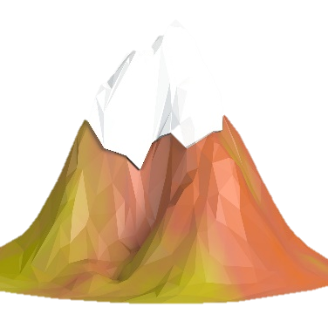

Image result for river blue lineImage result for river blue lineImage result for river blue lineImage result for river blue lineImage result for river blue lineImage result for river blue line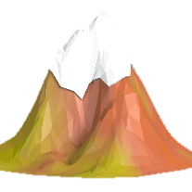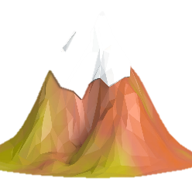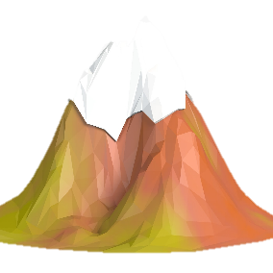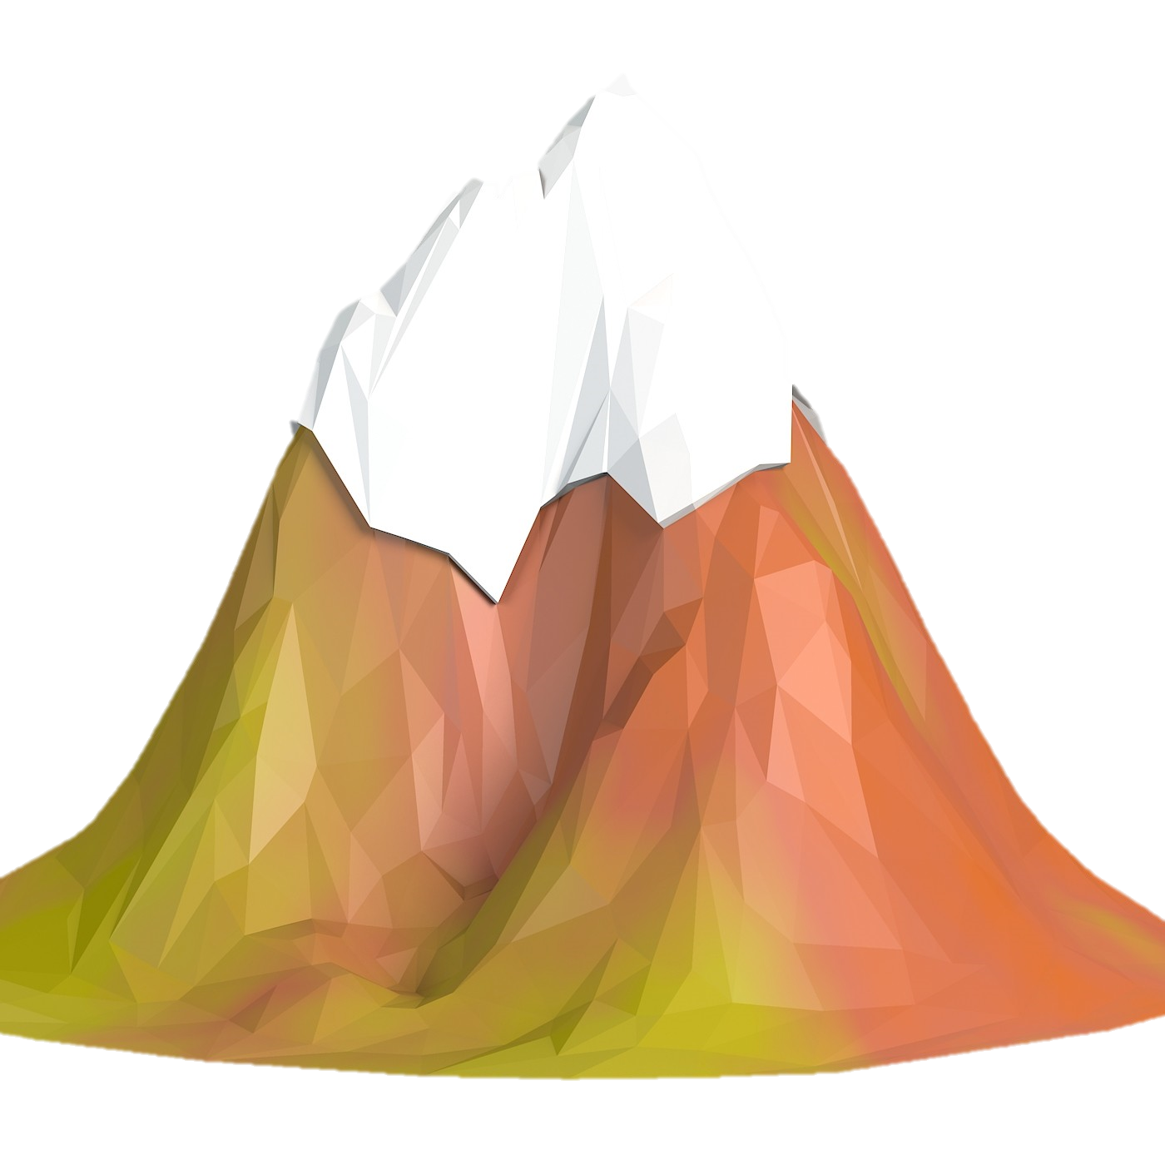

Tetnuldi– 4,850m

Shkhara – 5,193m

Elbrus – 5,642m

Dnieper – 2,201km

Longest Rivers

Highest Mountains

Pechora – 1,809km

Don – 1,870km

Ural – 2,428km

Danube – 2,850 km

Volga – 3,530km

Kazbek – 5,033m

Koshtan Tau – 5,151m

Dykh-Tau– 5,205m