Topic Overview
The Victorian period saw immense change in Britain. In this unit we will consider how inventions, the industrial revolution and the growth of the railways had an impact on society in Victorian Britain.
Inventions and technological change
- During the Victorian period, many famous inventions were created that solved problems and made life better for people

- Farm machinery inventions replaced the jobs that people used to do.

- The development of steam power meant that machines in factories were more powerful and goods were produced more quickly.

- The manufacture of steel proved very useful in building machines, ships, bridges and railways

- Steam power’s development also meant trains were more powerful and faster.

- The development of the railways influenced travel and trade.

Societal Change
Before the industrial revolution around 80% of people in Britain lived in the countryside. Most jobs were linked to farming the land.

- The industrial revolution saw a mass migration of people into towns and cities.

- Lots of factories were being built which meant there were lots of jobs on offer in the cities.

- Workers living conditions were cramped and unpleasant. Diseases spread easily.

- Industrialists became very rich and the country became wealthier.

- The new passenger steam railways meant people could travel around the country more easily and much more quickly. They did not have to rely on animals.

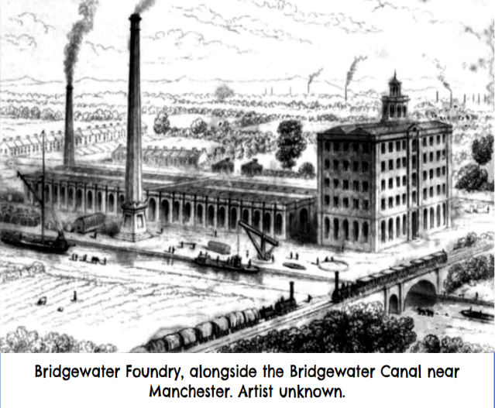

Key Vocabulary
Industry – the process of making products by using machines and factories
Revolution – a huge change in the way things are done
Invention- a new object or idea that has been created
Manufacture – to make something on a large scale using machinery
Trade – buying or selling goods
Population - people who live in a particular place
Rural – countryside
Pollution – harmful gases, smoke and chemical in the environment

Top Take-Aways
Having studied this topic you should be able to:

• Give examples of inventions that solved a problem or improved life for people

• Explain why people moved from the countryside to the city.

• Describe what the industrial revolution was and how Britain became wealthier but living conditions worsened

• Explain how the railways helped with the industrial revolution

- Describe why there was ‘Railway Mania

