**SCIENCE Year 1 Autumn Term 2 Everyday materials**

*Top takeaways:*

*• distinguish between an object and the material from which it is made*

*• identify and name a variety of everyday materials, including wood, plastic, glass, metal, water, and rock*

*• describe the simple physical properties of a variety of everyday materials*

*• compare and group together a variety of everyday materials on the basis of their simple physical properties*

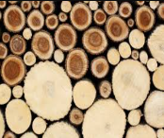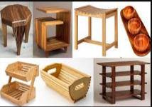**Identify and name these are materials: These are the materials that things are made from:**

wood wooden things include:

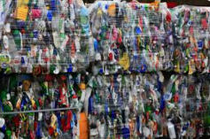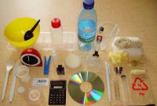plastic plastic things include:

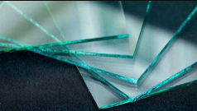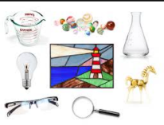

glass glass things include:

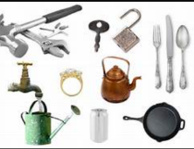

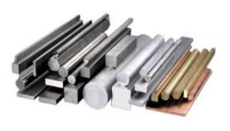

metal metal things include:



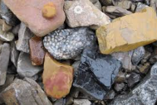rock rock things include:

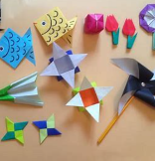paper or cardboard paper or cardboard things include:

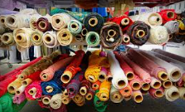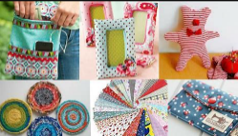fabric fabric things include:

**Vocabulary to describe what materials are like:**

hard soft

stiff stretchy

rough smooth

bendy not bendy (rigid)

waterproof not waterproof

transparent (see through) opaque (not see through)